Quiz 2 illustrations

3a.



3b



4a.



4b

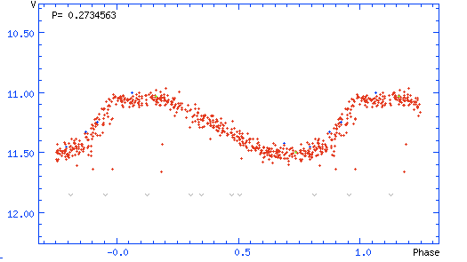

11.



12.

