**SPECIAL CHARTS-**from VSP Options

**Would you like a special chart?**

NoneBinocularStandard Field

Binocular: Only labels comparison stars useful for binocular viewing  
Standard Field: Only labels photometric "standard stars" in the chart's field of view

*special charts* depend upon a comment in the original sequence data upload (to the right of the #), i.e., 72,15,13,0.35,+49,46,30.8,7.247,0.032,1.178,0.036,NA,NA,NA,NA,NA,NA,NA,NA,1,#BINO_COMP

AUID Lookup Examples:

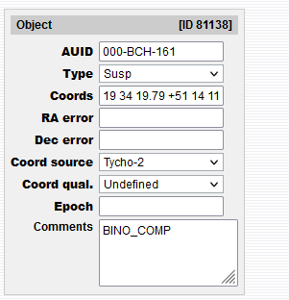

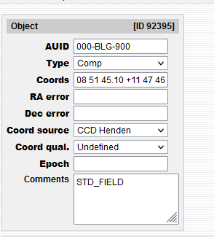

**Binocular Pgm**

<https://www.aavso.org/aavso-binocular-program>

The team created these sequences with the BINO_COMP comment and or simply marked some existing ones as being a BINO_COMP back in 2012.

This comment BINO_COMP is what allows only those so marked comps to show up when an observer selects the Binocular option under Special Charts. They will, of course show up on all regular charts (the NONE option) along with any other comps that exist within the selected fov.

A fair number of those sequence selections were suspected variables (small variations) that would exclude them from CCD use but adequate for Visual Use (note the *Susp* entry into type with the first example above).

It was decided not long thereafter that these ~ 150 FOV’s would be the extent of the Binocular Special sequences and no further additions would occur-see following exception.

Oct, 2021 Update. Sebastian Otero announced a **SuperNova Early Warning System (SNEWS)** project with ~ 200 targets. As many of these are suitable Binocular targets Sebastian choose to Use the BINO COMP identifier for selected comparison stars for many of these targets.

**Standard Fields**

<https://app.aavso.org/vsd/stdfields>

Selection of the Standard Field option selects photometric "standard stars" in the chosen chart's field of view that have been identified as suitable for CCD observers to create Transformation Coefficients.

Some of these FOV’s were created from Arne Henden’s data and some from Arlo Landolt’s data.

We are not authorized to add any additional Standard Fields to this list at this time.

FYI,

While the above link will take an observer directly to the Chart/Table (not a DSS image) by clicking on the name, none of these Standard Field names will bring up a chart when entered into the VSP; if the observer wants to so select a chart for one of the FOV’s listed, they have to use the coordinates of the Field Name within the VSP to pull up the Chart/Table.

In additional not all Standard Field links from a AAVSO Search bring up all the FOV’s shown with the above specific link, i.e., <https://www.aavso.org/standard-stars-vsp>.

Tim Crawford

8/11/2021

10/20/2021 Update Note

8/10/2021